Python

1. What is the output of the following code?
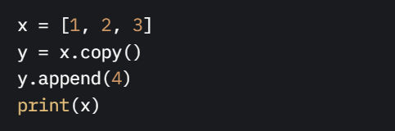
a) [1, 2, 3, 4]
b) [1, 2, 3]
c) [4]
d) Error

**Answer**: b) [1, 2, 3]

2. Which of the following creates a set comprehension for odd numbers from 1 to 10?
a) {x for x in range(1, 11) if x % 2 == 0}
b) {x for x in range(1, 11) if x % 2 != 0}
c) {x for x in range(1, 10) if x % 2 == 1}
d) {x for x in range(0, 10) if x % 2 != 0}

**Answer**: b) {x for x in range(1, 11) if x % 2 != 0}

3. What does the following code return?
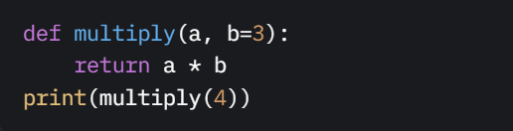
a) 12
b) 4
c) Error
d) None

**Answer**: a) 12

4. Which of the following correctly checks if an element exists in a set?
a) `if element in set.keys()`
b) `if element in set`
c) `if set[element] is not None`
d) `if element.exists(set)`

**Answer**: b) `if element in set`

5. What is the output of the following code?
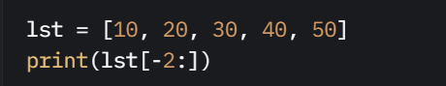
a) [30, 40]
b) [40, 50]
c) [50, 40]
d) [20, 30]

**Answer**: b) [40, 50]

6. What happens when you run this code?
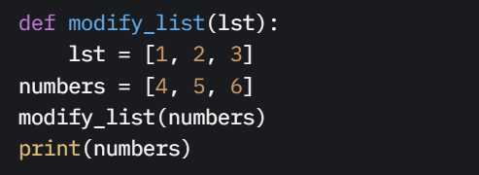
a) [1, 2, 3]
b) [4, 5, 6]
c) Error
d) None

**Answer**: b) [4, 5, 6]

7. What will the following code print?
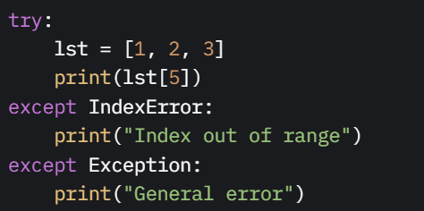
a) General error
b) Index out of range
c) Both messages
d) Error

**Answer**: b) Index out of range

8. What is the result of the following dictionary comprehension?
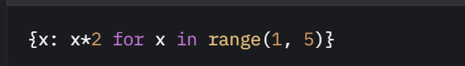
a) {1: 2, 2: 4, 3: 6, 4: 8}
b) {1: 1, 2: 2, 3: 3, 4: 4}
c) {2: 2, 4: 4, 6: 6, 8: 8}
d) {1: 2, 2: 4, 3: 6, 4: 8, 5: 10}

**Answer**: a) {1: 2, 2: 4, 3: 6, 4: 8}

9. Which of the following lambda functions correctly returns the sum of two numbers?
a) `lambda x, y: x + y`
b) `lambda x, y: x * y`
c) `lambda x, y: x - y`
d) `lambda: x + y`

**Answer**: a) lambda x, y: x + y

10. What is the output of the following code?
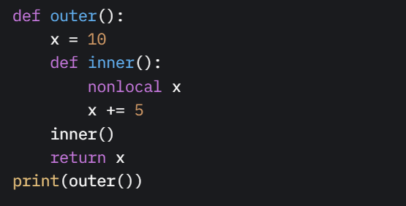
a) 10
b) 15
c) Error
d) 5

**Answer**: b) 15

Statistics
- What is the mean of the dataset [2, 4, 6, 8, 10]?
  - A) 5
  - B) 6
  - C) 7
  - D) 8
Correct Answer: B) 6
- What does the standard deviation measure in a dataset?
  - A) Central tendency
  - B) Spread of data
  - C) Frequency of values
  - D) Correlation between variables
Correct Answer: B) Spread of data
- What is the median of the dataset [1, 3, 5, 7, 9]?
  - A) 3
  - B) 5
  - C) 7
  - D) 9
Correct Answer: B) 5
- What is a p-value in hypothesis testing?
  - A) Probability of rejecting the null hypothesis
  - B) Probability of the null hypothesis being true
  - C) Probability of observing the data given the null hypothesis
  - D) Probability of accepting the alternative hypothesis
Correct Answer: C) Probability of observing the data given the null hypothesis
- Which measure is affected most by extreme values in a dataset?
  - A) Median
  - B) Mode
  - C) Mean
  - D) Midrange
Correct Answer: C) Mean

Machine Learning
- What is the purpose of a training set in machine learning?
  - A) To evaluate the model’s performance
  - B) To tune hyperparameters
  - C) To fit the model
  - D) To test the model
Correct Answer: C) To fit the model
- Which algorithm is commonly used for classification tasks?
  - A) Linear Regression
  - B) K-Means Clustering
  - C) Logistic Regression
  - D) Principal Component Analysis
Correct Answer: C) Logistic Regression
- What is overfitting in machine learning?
  - A) Model performs well on training data but poorly on test data
  - B) Model performs poorly on both training and test data
  - C) Model is too simple to capture patterns
  - D) Model cannot be trained
Correct Answer: A) Model performs well on training data but poorly on test data
- What does the following Scikit-learn code do?
  - 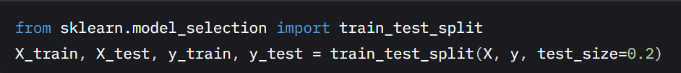A) Scales the features
  - B) Splits data into training and test sets
  - C) Fits a model
  - D) Evaluates model performance
  - Correct Answer: B) Splits data into training and test sets
  - Explanation: train_test_split divides the dataset into training and test sets.
- Which metric is used to evaluate a classification model’s performance?
  - A) Mean Squared Error
  - B) R-squared
  - C) Accuracy
  - D) Root Mean Squared Error
Correct Answer: C) Accuracy
- What is the purpose of cross-validation in machine learning?
  - A) To preprocess data
  - B) To reduce model complexity
  - C) To assess model performance robustly
  - D) To select features
Correct Answer: C) To assess model performance robustly
- What is the output of the following code?
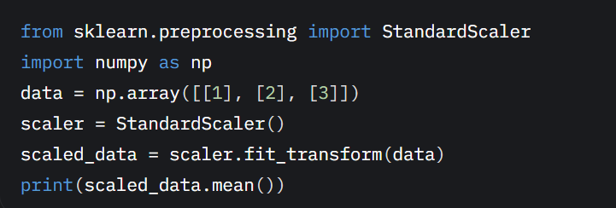
  - A) 0
  - B) 1
  - C) 2
  - D) Error
Correct Answer: A) 0
- Which algorithm is an example of unsupervised learning?
  - A) Decision Tree
  - B) K-Means Clustering
  - C) Support Vector Machine
  - D) Linear Regression
Correct Answer: B) K-Means Clustering
- What is the role of a loss function in machine learning?
  - A) To split the dataset
  - B) To measure model error
  - C) To select features
  - D) To visualize data
Correct Answer: B) To measure model error
- What does the fit() method do in Scikit-learn?
  - A) Evaluates the model
  - B) Trains the model
  - C) Predicts new data
  - D) Scales the data
Correct Answer: B) Trains the model
- What is the purpose of regularization in machine learning?
  - A) To increase model complexity
  - B) To prevent overfitting
  - C) To speed up training
  - D) To reduce dataset size
Correct Answer: B) To prevent overfitting
- Which of the following is a hyperparameter in a Random Forest model?
  - A) Number of trees
  - B) Predicted labels
  - C) Feature weights
  - D) Training data
Correct Answer: A) Number of trees
- What does the following code do?
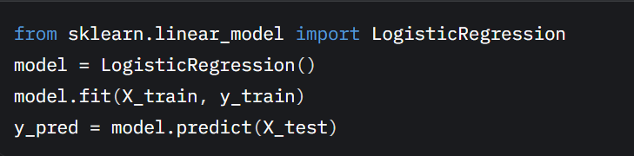
  - A) Scales the test data
  - B) Trains and predicts using a logistic regression model
  - C) Performs cross-validation
  - D) Clusters the data
Correct Answer: B) Trains and predicts using a logistic regression model
- What is the purpose of a confusion matrix?
  - A) To visualize feature importance
  - B) To evaluate classification model performance
  - C) To scale features
  - D) To reduce dimensionality
Correct Answer: B) To evaluate classification model performance
- What is the main advantage of using a decision tree?
  - A) Handles non-linear relationships
  - B) Requires no preprocessing
  - C) Always provides the best accuracy
  - D) Reduces dataset size
Correct Answer: A) Handles non-linear relationships

